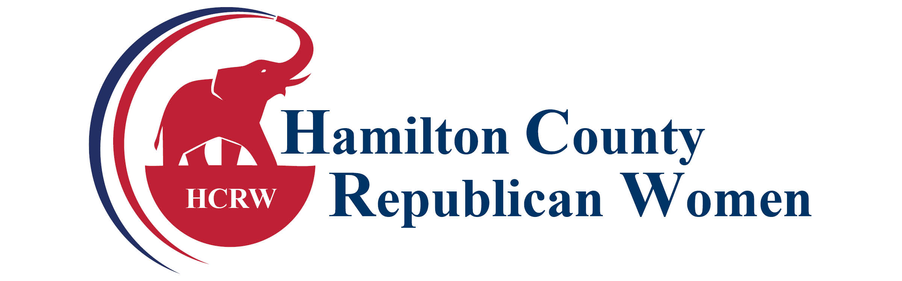
2024 Membership Application
Your membership to the Hamilton County Republican Women’s Club includes our obligations and benefits to the Indiana Federation of Republican Women (IFRW) and the National Federation of Republican Women (NFRW). The breakdown of the fees for membership is as follows: HCRW $10, IFRW $10, NFRW $20.
Date: ___________________

___ Renewal Member: $40 (GOP Woman & Hamilton County Resident)
___ Associate Member: $40 (GOP Man or Non-County GOP Woman) – fees retained locally
___ Stars & Stripes Donor: $ __________ (Additional donation to the local club)
___ New Member: Dues $40 (if referred by a current member please list member’s name)
_____________________________________________

***CONTACT INFORMATION TO BE UPDATED EACH YEAR: Please fill out
Name ________________________________________________________________
Address ______________________________________________________________
City/State/Zip _________________________________________________________
Home/Cell ______________________Work __________________________________
Email_________________________________________________________________
If paying by check, please make your check payable to HCRW and mail it with the application to: Hamilton County Republican Women’s Club, Attention: Treasurer, PO Box 430, Westfield, IN 46074.
CREDIT CARD INFORMATION: - Only Complete if you are not including a check.
** Please add an additional $3.00 for dues paid though Square to cover fees for a total of $43.00.
Credit Card Type: □ Mastercard □ Visa □ American Express □ Discover
Number:______________________________________________________________
Expiration Month:____________Expiration Year:____________Security Code:______
Cardholder’s Signature:_______________________________Date:___/____/______
Contact President, Adrienne Rogers with any questions at 317-797-7035 or email at hamcogopwomen@gmail.com. Visit our website www.HamCoGOPWomen.org.

