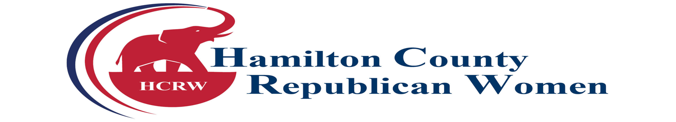
2024 SPONSORSHIP FORM
$500 PLATINUM
Entry for 2 to all HCRW Club events, 2 club memberships, verbal acknowledgement, listed on sponsor board, and spotlighted as a sponsor on Facebook and the HCRW Club website. You may speak about yourself/the office for 10 minutes at 1 meeting of your choice.
$400 GOLD
Entry for 2 to all HCRW Club events, 2 club memberships, verbal acknowledgement, sponsor board and spotlighted as a sponsor on Facebook and the HCRW Club website.
$300 SILVER
Entry for 1 to all HCRW Club events, 1 club membership, verbal acknowledgement at meetings and listed on sponsor board.
$200 BRONZE
Entry for 1 to all HCRW Club events, 1 club membership, verbal acknowledgement.
Name as listed on Acknowledgment: _______________________________________________
Sponsorship Level: _____________________________________________________________
Address: _____________________________________________________________________
Email: _______________________________________________________________________
Phone: _______________________________________________________________________
Club Member Name(s): __________________________________________________________
Please make your check payable to HCRW and mail it with the sponsorship form to: Hamilton County Republican Women’s Club, Attention: Treasurer, P.O. Box 430, Westfield, IN 46074.
To submit your sponsorship through a credit card, please mail the application and contact Treasurer Lisa Elmore at 812-240-5181 to process your payment through the Square.
Please contact President, Adrienne Rogers at 317-797-7035 or hamcogopwomen@gmail.com with questions. Visit our website www.HamCoGOPWomen.org.

